**Git Deploy Servidor Remoto**

**Servidor remoto**

Crear dos carpetas

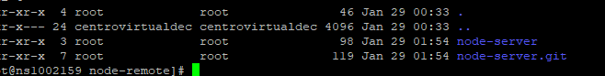

Dentro de la carpeta node-server.git, ejecutar el siguiente comando:

git init –bare

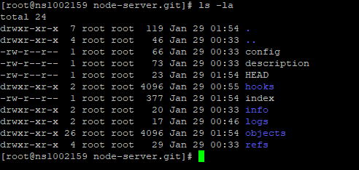

Dentro de la carpeta Hooks crear el archivo post-receive

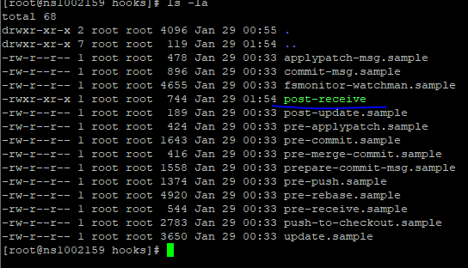

Agregar el siguiente contenido:

#!/bin/bash

TARGET="/home/centrovirtualdec/public_html/node-remote/node-server"

GIT_DIR="/home/centrovirtualdec/public_html/node-remote/node-server.git"

BRANCH="master"

while read oldrev newrev ref

do

# only checking out the master (or whatever branch you would like to deploy)

if [ "$ref" = "refs/heads/$BRANCH" ];

then

echo "Ref $ref received. Deploying ${BRANCH} branch to production..."

if git --work-tree=$TARGET --git-dir=$GIT_DIR checkout -f $BRANCH; then

cd "$TARGET" && npm install

echo "Restart reload pm2\n"

pm2 restart 1

pm2 logs 1

echo "PM2 finished\n"

else

echo "Error Reload PM2"

fi

else

echo "Ref $ref received. Doing nothing: only the ${BRANCH} branch may be deployed on this server."

fi

done

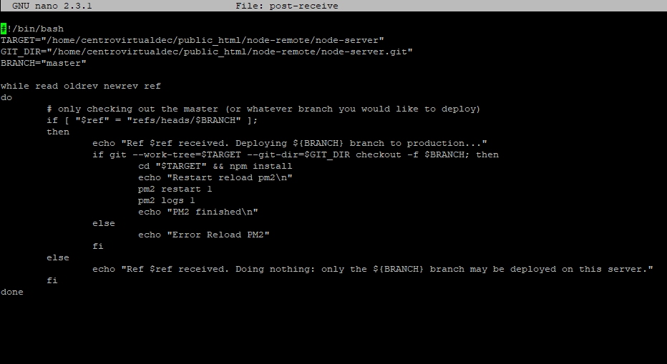

**Servidor local**

Git init

Git add .

Git commit -m “Test”

Git remote add production [root@92.204.128.123:/home/centrovirtualdec/public_html/node-remote/node-server.git](mailto:root@92.204.128.123:/home/centrovirtualdec/public_html/node-remote/node-server.git)

Git push -u production master